Student Name: | Eidhne Kennedy
ID Number: | 21347021
Degree Name: | Computer Science
Assessment: | EE130 EEE-CA-1

Continuous Assessment: Electrical/Electronic Innovators

Description and purpose

You will learn about two Electrical & Electronic Engineering innovators and entrepreneurs through two videos.

The first video about Nikola Tesla was recorded on 10th September 2020 with Professor W Bernard Carlson, Lecturer in TechInnovate (EEE, School of Engineering, NUI Galway) and Director of Engineering Business Programmes at the University of Virginia. Professor Carlson teaches on the Masters of AgInnovation and TechInnovation postgraduate programmes at NUI Galway.

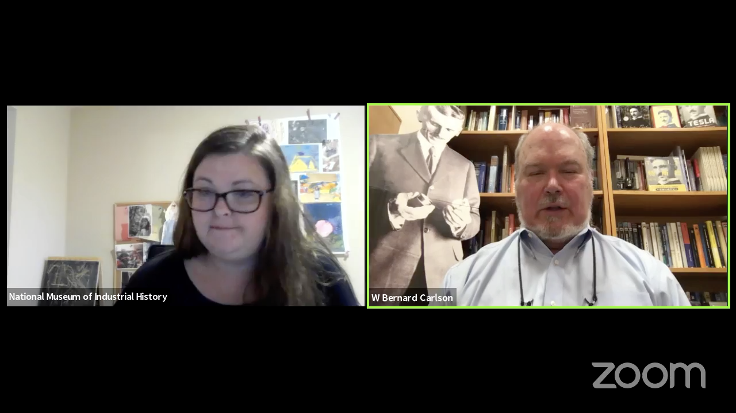

The second video with Galway entrepreneur Shankar Ganesh Jayagopi, founder and CEO of Magnus Monitors, was recorded during an EI140 EEE lecture in 2019.

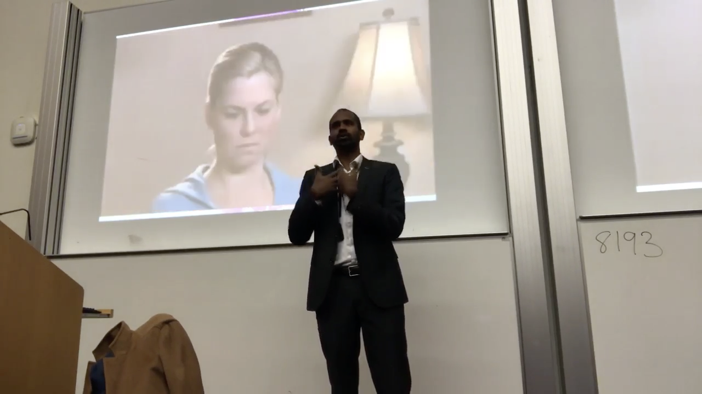

Please watch both of these videos and then answer the questions below. You may consult external resources as necessary, but please also read the note on plagiarism that follows.

Objectives

- To learn about the practicalities of taking an engineering invention and commercialising it.
- To reflect on what you learned from both of these videos.

Task

(You will upload this file when completed as a Word or PDF document to the Blackboard area for EE130 -> Assessment -> EEE -> EEE-CA-1 Electrical/Electronic Innovators Submission.)

Question | 40 words minimum; 100 words maximum per answer
Give a summary of Tesla’s background and his journey towards becoming an electrical engineering inventor: | Born a Serb in the Austro-Hungarian empire in 1856, suffered from extreme nightmares as a child. Studied engineering in Austria, worked for Edison companies in Budapest, Paris, and New York. 1886, started developing an a.c. motor based on a rotating magnetic field in the stator of the motor, as opposed to the rotor (where all prior fields were located). Sold patent to George Westinghouse, and worked for him until 1889. Met Heinrich Hertz, who was working on radio waves, then scaled up his apparatus to create the tesla coil.  However, couldn’t get backers for wireless power due to a recession.
Give a summary of Shankar’s background and his journey towards becoming an electronic and computer engineering entrepreneur: | Went to college for instrumentation and control engineering, despite originally wanting to study computer science, and was recruited by Cisco, where he learned to be a programmer in a professional environment. He did a masters in computer science with support from Cisco, and moved to Ireland to take up a position with them here. Started a business through the new frontiers programme while on sabbatical from cisco, Instillo, which was able to sustain his own lifestyle, and allow him to employ several other people. They then developed course ranger, an app for golf, so they had software and hardware products.
Which of Tesla’s various product ideas sounded most interesting or innovative to you, and why? | Wireless powered motors, although I’m not sure if they’re actually implementable, but they would reduce the space taken up in most modern machinery by cables, making them a lot more efficient in terms of their power to weight ratio.
Which of Shankar’s various product ideas sounded most interesting or innovative to you, and why? | Most likely the instillo project, it’s a lot more efficient to use a simpler and cheaper device to perform a specific function, than to install higher-level machines, which are often less secure and have more chances to malfunction due to being less specialised, for the majority of circumstances.
What do you believe is the world’s most important electrical or electronic engineering innovation [an invention that has been com- mercialised], and why do you consider it to be so? | The GNU project: originally started in 1983 by Richard Stallman in an attempt to curb the commercialisation of the internet and continue the tradition of free sharing of software. The object of the project was to write an operating system free from constraints on the use of its source code, and stands even today as a testament to the human ability to work without a profit incentive, and as a clear statement of the increased quality of work done to fill a need, and not to generate profits.

Reminder: Upload this file when completed as a Word or PDF document to the Blackboard area for EE130 -> Assessment -> EEE -> EEE-CA-1 Electrical/Electronic Innovators Submission. And don’t forget to fill in your name, ID and degree at the very top of this document.

Please note that plagiarism is a serious matter and it will be detected using Turnitin. Please read the University policy on plagiarism in advance at: http://www.nuigalway.ie/plagiarism/

The End

